LAB NO# (03)

LAB TITLE:
“TO PRINT THE PROGRAM OF SUM AND SUBTRACTION OF INTEGERS & CHARCTER INPUT BY USER AND GET THE SUM OF AND SUBTRACTION OF INTEGERS”
OBJECTIVE:
Type and run a program that show the sum and subtraction of integers that’s the first task and second task that take the input form user to enter first integer and second integer and show the sum and subtraction.
TOOLS:
- Pc/laptop
- Code block software.

PROCDURES:
1) First of all open the code block software in your Pc/Laptop.
2) Then create a new project in C++ and save in some folder.
3) After that you will get new interface and the following code for simply addition and subtraction of 2 integers or more.
#include <iostream>
using namespace std;
int main(){
int a=6;
int b=7;
int sum=a+b;
cout<<”the two number sum is”<<sum<<endl;
return0;
}
This code show simply and we change the sign from plus to minus then it show the subtraction
ADDITION
INPUT
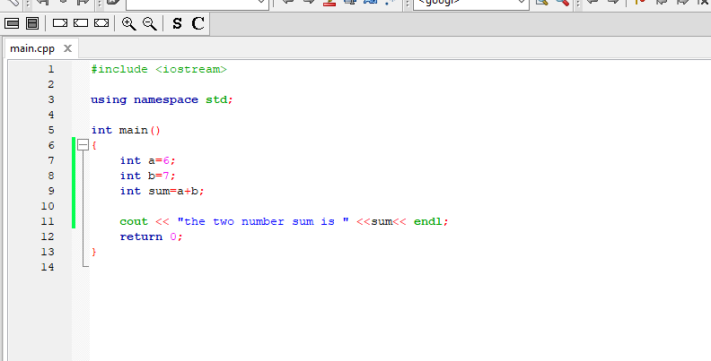OUTPUT
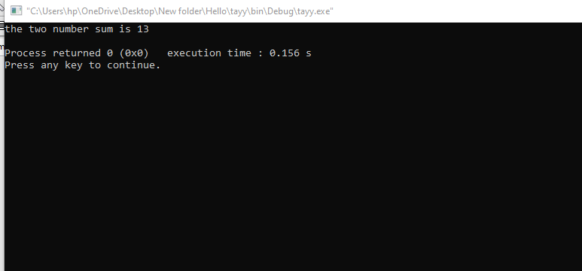

SUBTRACTION
INPUT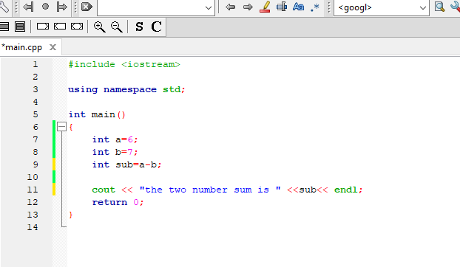
OUTPUT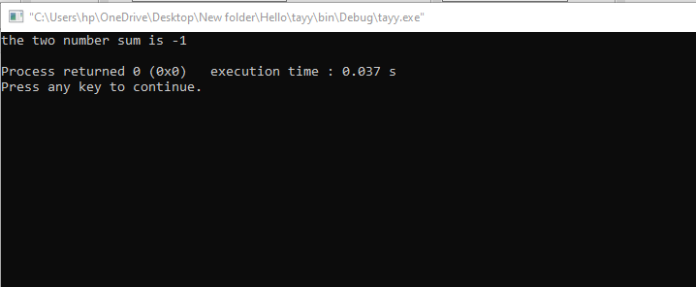
4) After completion of first task we need to do the second task we need charter input statement (cin).
5) We simply type this code to get user intput.
INPUT
#include <iostream>
using namespace std;
int main()
{
int a;
int b;
cout<<"Enter first number:" <<endl;
cin>>a;
cout <<"Enter second number:"<<endl;
cin>>b;
int sum=a+b;
cout<<"That is the sum of these number:"<<sum<<endl;
return 0;
}
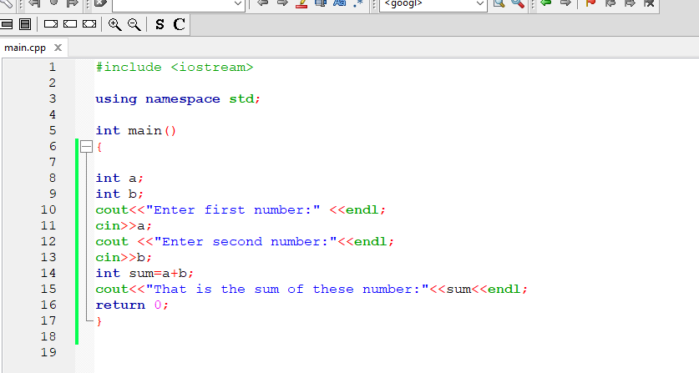

OUTPUT
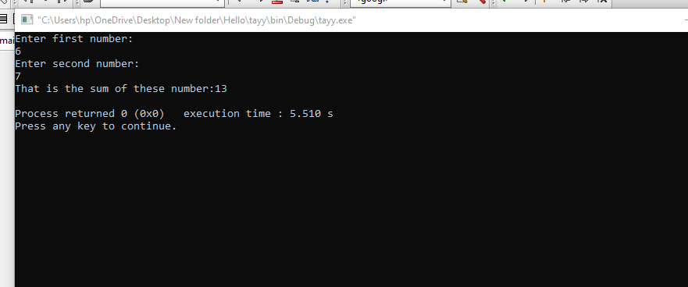

OBSERVATION
IF ANY ONE OF THE CODE IS WRONG THE WHOLE PROGRAM WILL BE WORNG AND WILL NOT BE ABLE TO RUN

